File Ujian_bvn.java

|  |
| --- |
| /*  * Click nbfs://nbhost/SystemFileSystem/Templates/Licenses/license-default.txt to change this license  */  package me.boven;  import me.boven.controller.KaryawanController;  import me.boven.service.KaryawanService;  import me.boven.view.KaryawanView;  import org.springframework.boot.ApplicationArguments;  import org.springframework.boot.ApplicationRunner;  import org.springframework.boot.SpringApplication;  import org.springframework.boot.autoconfigure.SpringBootApplication;  import org.springframework.beans.factory.annotation.Autowired;  import org.springframework.context.ApplicationContext;  /**  *  * @author WINDOWS 10  */  @SpringBootApplication  public class Ujian_bvn implements ApplicationRunner {  @Autowired  private KaryawanService karyawanService;  public static void main(String[] args) {  System.setProperty("java.awt.headless", "false"); // Disable headless mode  // Start the Spring application and get the application context  ApplicationContext context = SpringApplication.run(Ujian_bvn.class, args);  // Instantiate the view and inject the controller manually  KaryawanController controller = context.getBean(KaryawanController.class);  KaryawanView mahasiswaView = new KaryawanView(controller);  mahasiswaView.setVisible(true);  }  @Override  public void run(ApplicationArguments args) throws Exception {  }  } |

File KaryawanController.java

|  |
| --- |
| /*  * Click nbfs://nbhost/SystemFileSystem/Templates/Licenses/license-default.txt to change this license  * Click nbfs://nbhost/SystemFileSystem/Templates/Classes/Class.java to edit this template  */  package me.boven.controller;  import org.springframework.beans.factory.annotation.Autowired;  import org.springframework.web.bind.annotation.*;  import me.boven.model.ModelKaryawan;  import me.boven.service.KaryawanService;  import java.util.List;  import org.springframework.stereotype.Controller;  @Controller  public class KaryawanController {  @Autowired  private KaryawanService karyawanService;  // Add new Mahasiswa  public String addKaryawan(@RequestBody ModelKaryawan krw) {  karyawanService.addK(krw);  return "Karyawan added successfully";  }  // Get Mahasiswa by ID  public ModelKaryawan getKaryawan(@PathVariable int id) {  return karyawanService.getK(id);  }  // Update Mahasiswa  public String updateKaryawan(@RequestBody ModelKaryawan krw) {  karyawanService.updateK(krw);  return "Karyawan updated successfully";  }  // Delete Mahasiswa by ID  public String deleteMahasiswa(@PathVariable int id) {  karyawanService.deleteK(id);  return "Mahasiswa deleted successfully";  }  // Get all Mahasiswa  public List<ModelKaryawan> getAllK() {  return karyawanService.getAllK();  }  } |

File ModelKaryawan.java

|  |
| --- |
| /*  * Click nbfs://nbhost/SystemFileSystem/Templates/Licenses/license-default.txt to change this license  * Click nbfs://nbhost/SystemFileSystem/Templates/Classes/Class.java to edit this template  */  package me.boven.model;  import jakarta.persistence.*;  /**  *  * @author Lenovo  */  @Entity  @Table(name = "karyawan")  public class ModelKaryawan {  @Id  @GeneratedValue(strategy = GenerationType.IDENTITY)  @Column(name = "ID")  private int id;  @Column(name = "Nama", nullable = false, length = 8)  private String nama;  @Column(name = "Jabatan", nullable = false, length = 50)  private String jabatan;  @Column(name = "Gaji")  private int gaji;  //Buka code -> generate -> constructor -> all  //code -> generate -> setter and getter -> All  //Baru buat anotasi @ nya      // constructor kosong untuk ORM  public ModelKaryawan() {  }    //constructor ada isinya untuk dipanggil di aplikasi  public ModelKaryawan(int id, String nama, String jabatan, int gaji) {  this.id = id;  this.nama = nama;  this.jabatan = jabatan;  this.gaji = gaji;  }  public int getId() {  return id;  }  public void setId(int id) {  this.id = id;  }    public String getNama() {  return nama;  }  public void setNama(String nama) {  this.nama = nama;  }  public String getJabatan() {  return jabatan;  }  public void setJabatan(String jabatan) {  this.jabatan = jabatan;  }  public float getGaji() {  return gaji;  }  } |

File ModelTabelKaryawan.java

|  |
| --- |
| /*  * Click nbfs://nbhost/SystemFileSystem/Templates/Licenses/license-default.txt to change this license  * Click nbfs://nbhost/SystemFileSystem/Templates/Classes/Class.java to edit this template  */  package me.boven.model;  import javax.swing.table.AbstractTableModel;  import java.util.List;  public class ModelTabelKaryawan extends AbstractTableModel{  private List<ModelKaryawan> karyawanList;  private String[] columnNames = {"ID", "NAMA", "JABATAN", "GAJI"};  public ModelTabelKaryawan(List<ModelKaryawan> karyawanList) {  this.karyawanList = karyawanList;  }  @Override  public int getRowCount() {  return karyawanList.size(); // Jumlah baris sesuai dengan jumlah data mahasiswa  }  @Override  public int getColumnCount() {  return columnNames.length; // Jumlah kolom sesuai dengan jumlah elemen dalam columnNames  }  @Override  public Object getValueAt(int rowIndex, int columnIndex) {  ModelKaryawan karyawan = karyawanList.get(rowIndex);  switch (columnIndex) {  case 0:  return karyawan.getId();  case 1:  return karyawan.getNama();  case 2:  return karyawan.getJabatan();  case 3:  return karyawan.getGaji();  default:  return null;  }  }  @Override  public String getColumnName(int column) {  return columnNames[column]; // Mengatur nama kolom  }  @Override  public boolean isCellEditable(int rowIndex, int columnIndex) {  return false; // Semua sel tidak dapat diedit  }  // Method untuk menambahkan atau memodifikasi data, jika dibutuhkan  public void setKaryawanList(List<ModelKaryawan> karyawanList) {  this.karyawanList = karyawanList;  fireTableDataChanged(); // Memberitahu JTable bahwa data telah berubah  }  } |

File KaryawanRepository.java

|  |
| --- |
| /*  * Click nbfs://nbhost/SystemFileSystem/Templates/Licenses/license-default.txt to change this license  * Click nbfs://nbhost/SystemFileSystem/Templates/Classes/Class.java to edit this template  */  package me.boven.repository;  import me.boven.model.ModelKaryawan;  import org.springframework.data.jpa.repository.JpaRepository;  import org.springframework.stereotype.Repository;  /**  *  * @author WINDOWS 10  */  @Repository  public interface KaryawanRepository extends JpaRepository<ModelKaryawan, Integer> {    } |

File KaryawanService.java

|  |
| --- |
| /*  * Click nbfs://nbhost/SystemFileSystem/Templates/Licenses/license-default.txt to change this license  * Click nbfs://nbhost/SystemFileSystem/Templates/Classes/Class.java to edit this template  */  package me.boven.service;  import me.boven.model.ModelKaryawan;  import me.boven.repository.KaryawanRepository;  import java.util.List;  import org.springframework.beans.factory.annotation.Autowired;  import org.springframework.stereotype.Service;  /**  *  * @author WINDOWS 10  */  @Service  public class KaryawanService {    @Autowired  private KaryawanRepository repository;  public void addK(ModelKaryawan krw) {  repository.save(krw);  }  public ModelKaryawan getK(int id) {  return repository.findById(id).orElse(null);  }  public void updateK(ModelKaryawan krw) {  repository.save(krw);  }  public void deleteK(int id) {  repository.deleteById(id);  }  public List<ModelKaryawan> getAllK() {  return repository.findAll();  }  } |

File KaryawanView.java

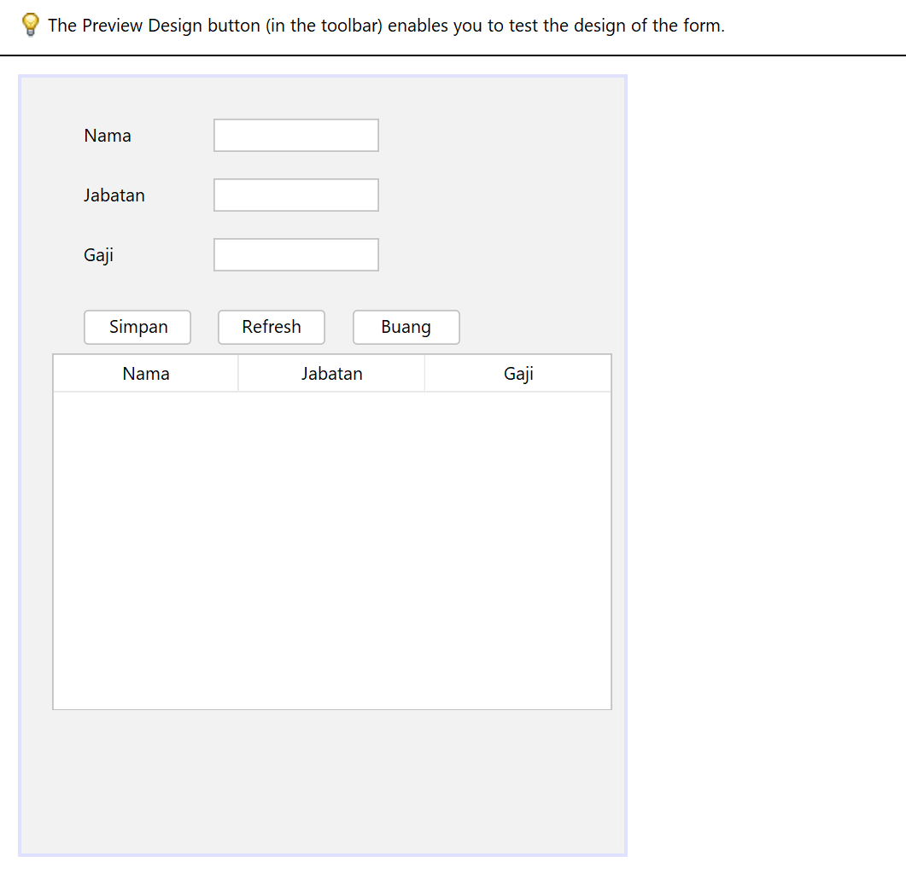

Output Program :

